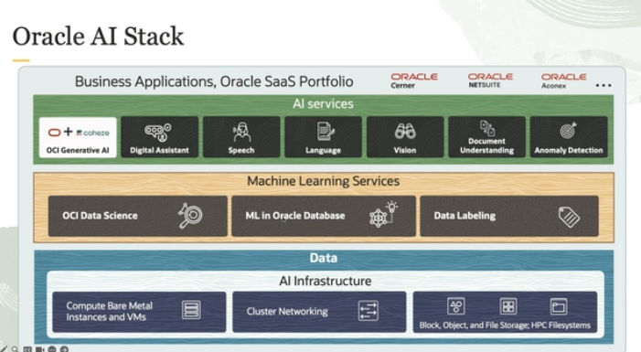

In this lesson, we will learn about OCI AI Infrastructure. Oracle AI stack consists of AI services and machine learning services. These services are built using AI infrastructure. In this lesson, our focus will be on OCI AI Infrastructure.

OCI AI Infrastructure is mainly composed of GPU-based instances. Instances can be virtual machines or bare metal machines, high performance cluster networking that allows instances to communicate to each other. Super clusters are a massive network of GPU instances with multiple petabytes per second of bandwidth. And a variety of fully managed storage options from a single byte to exabytes without upfront provisioning are also available. Let us explore each of these components further.

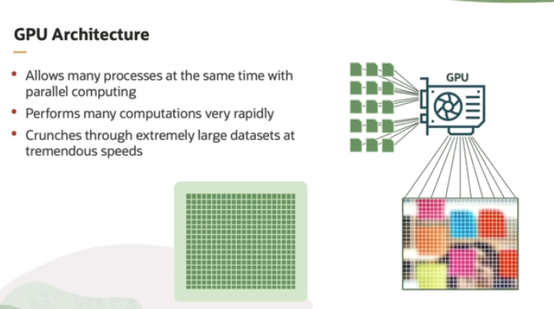

The explanation highlights the importance of GPUs (Graphics Processing Units) in machine learning (ML) and artificial intelligence (AI) tasks, particularly for handling large-scale computations efficiently. Here's a breakdown:

1. **Repetitive Computations in ML/AI**: Machine learning and AI involve processing vast amounts of data and performing the same kinds of mathematical operations repeatedly (e.g., matrix multiplications, backpropagation in neural networks). These tasks are computationally intensive.
2. **Need for Speed**: The more data and the more complex the models, the greater the demand for computational power. Handling large datasets efficiently is crucial for training machine learning models quickly.
3. **Parallel Computing on GPUs**: GPUs are designed for parallel computing, which means they can perform multiple calculations simultaneously. This makes them ideal for ML/AI because these fields require processing lots of data in parallel.
4. **GPU Architecture**: A GPU has thousands of small, lightweight cores. Each core is responsible for handling a small portion of the data, and they work together in parallel to process the entire dataset quickly. This is in contrast to a traditional CPU, which has fewer cores and is better suited for tasks requiring sequential processing.
5. **Speed and Efficiency**: Due to their parallel architecture, GPUs can handle enormous datasets and perform computations at much higher speeds than CPUs, which is essential for training complex machine learning models in a reasonable amount of time.

In summary, GPUs are essential in ML and AI because they can perform many computations in parallel, which significantly speeds up data processing and model training.

Here are some of the most famous and widely-used GPUs for AI processing:

**1. NVIDIA A100 (Ampere Architecture)**

* **Use case**: Designed specifically for AI, machine learning, and data analytics.
* **Features**: 6912 CUDA cores, 432 Tensor cores, and 40 GB/80 GB HBM2 memory.
* **Strength**: High performance for AI model training, inference, and deep learning applications.

**2. NVIDIA V100 (Volta Architecture)**

* **Use case**: Often used in data centers for AI, deep learning, and high-performance computing (HPC).
* **Features**: 640 Tensor cores, 16 GB/32 GB HBM2 memory.
* **Strength**: Popular for training AI models and running complex neural networks.

**3. NVIDIA RTX 3090 (Ampere Architecture)**

* **Use case**: Primarily a high-end consumer GPU, but also widely used for AI model training and inference, especially in smaller setups.
* **Features**: 10,496 CUDA cores, 24 GB GDDR6X memory.
* **Strength**: Excellent for deep learning at a relatively lower price compared to data-center GPUs.

**4. NVIDIA Titan RTX**

* **Use case**: A prosumer (professional consumer) GPU used for AI research, deep learning, and 3D rendering.
* **Features**: 4,608 CUDA cores, 24 GB GDDR6 memory.
* **Strength**: Suitable for AI researchers and developers, balancing performance and cost.

**5. NVIDIA T4 (Turing Architecture)**

* **Use case**: Designed for AI inference, deep learning, and cloud-based services.
* **Features**: 320 Tensor cores, 16 GB GDDR6 memory.
* **Strength**: Widely deployed in cloud environments due to its energy efficiency and versatility in AI tasks.

**6. NVIDIA A40**

* **Use case**: Targets AI, data analytics, and visualization workloads.
* **Features**: 10,752 CUDA cores, 48 GB GDDR6 memory.
* **Strength**: Optimized for both AI and data visualization, allowing it to handle complex neural networks and visualization simultaneously.

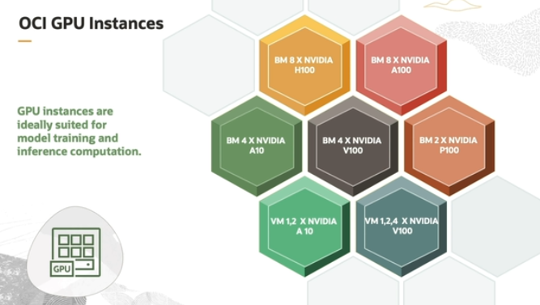

In the context of GPU instances for AI processing, the explanation highlights the use of high-performance hardware for both training and inference tasks in machine learning and AI. Let me break it down in detail:

1. **GPU Instances for Training and Inference**:
   * GPU instances (computing units that include powerful GPUs) are highly optimized for both training machine learning models and making predictions (inference) from those models.
   * Training typically requires significant computational power as it involves processing large datasets and adjusting model parameters. Inference, on the other hand, involves using a trained model to make predictions on new data, which also benefits from GPU acceleration.
2. **Bare Metal vs. Virtual Machine Instances**:
   * **Bare metal instances**: These are physical servers that provide direct access to the hardware, ensuring maximum performance without the overhead of virtualization. This is particularly useful for workloads that require high-performance computing, such as large-scale AI training and data analytics.
   * **Virtual machine (VM) instances**: These are virtualized environments where multiple instances can share the same physical hardware. They are more flexible and can be used for smaller-scale AI training or tasks that don’t need the full power of a bare metal server.
3. **NVIDIA GPUs Provided by OCI (Oracle Cloud Infrastructure)**:
   * **NVIDIA H100, A100, A10, and B100** GPUs: These are some of the most advanced GPUs available, designed specifically for high-performance computing and AI workloads.
     + **H100 and A100**: The most powerful options, optimized for large-scale training and inference. They offer significant acceleration for deep learning tasks, enabling faster model training and more efficient inference.
     + **A10 and B100**: These GPUs are more suited for smaller-scale AI tasks or applications like streaming, gaming, and virtual desktops.
4. **Large-Scale AI Training and Data Analytics**:
   * **BM 8 X NVIDIA H100 and BM 8 X NVIDIA A100**: These are bare metal instances equipped with eight NVIDIA H100 or A100 GPUs. These configurations are tailored for demanding AI training, data analytics, and high-performance computing workloads.
   * These instances provide:
     + **9x Faster Training**: Due to the high computational power of these GPUs, training machine learning models can be significantly faster compared to standard GPU setups.
     + **30x Higher Acceleration for Inference**: These GPUs dramatically improve the speed at which AI models can make predictions, which is crucial for real-time applications like autonomous systems, recommendation engines, and large-scale analytics.
5. **Other Use Cases**:
   * Other configurations of bare metal and virtual machine instances are designed for less intensive AI workloads, such as:
     + **Small AI training**: For models that are less computationally expensive.
     + **Inference**: Predicting or classifying data using trained models in a more lightweight setting.
     + **Streaming, Gaming, and Virtual Desktop Infrastructure (VDI)**: These applications leverage GPUs for rendering graphics, video processing, and handling high-performance virtualized environments.

In summary, the different GPU instances provided by OCI cater to a wide range of AI-related tasks, from large-scale AI training with bare metal configurations to smaller workloads with virtual machine instances. High-end GPUs like NVIDIA H100 and A100 are key enablers for fast training and efficient inference, driving substantial performance improvements for AI applications.

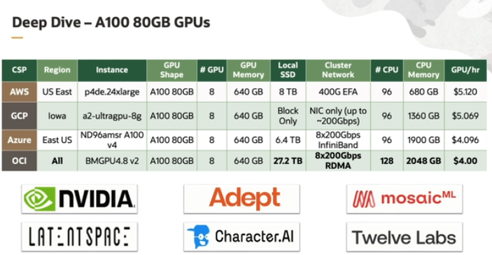

Oracle offers all the features and is the most cost effective option when compared to its counterparts. For example, BMGPU4.8 version 2 instance costs just $4 per hour and is used by many customers.

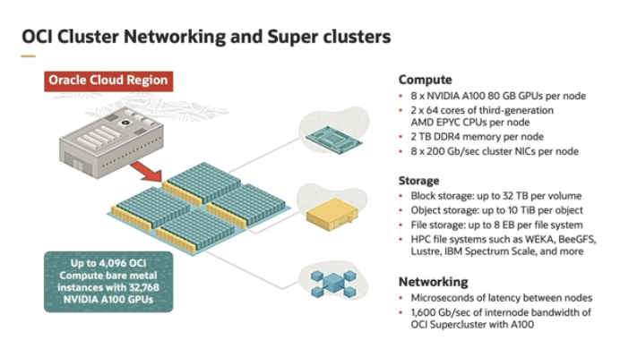

This explanation provides insight into the **superclusters** used for high-performance AI and computing tasks, particularly within the **Oracle Cloud Infrastructure (OCI)** environment. Here's a detailed breakdown of the key elements:

**1. Superclusters:**

* **Massive Network**: Superclusters represent a highly interconnected network of computing resources, with multiple petabits (1 petabit = 1 million gigabits) of bandwidth available. This high bandwidth enables extremely fast data transfer between the nodes of the supercluster, which is crucial for training large AI models and handling big data.
* **Scale**: A supercluster can scale up to include **4,096 OCI bare metal instances**, which are physical servers providing raw computational power without virtualization overhead. This can include up to **32,768 GPUs** working together in parallel.

**2. Choice of GPUs:**

* Users have the option to choose between **bare metal instances powered by NVIDIA A100 or H100 GPUs**. These are some of the most advanced GPUs designed for AI workloads, especially in deep learning and large-scale data analytics.
* **A100 GPUs** are designed for AI training and inference, providing excellent performance in neural network tasks.
* **H100 GPUs** are even more powerful, offering next-generation performance, and are ideal for handling the most intensive AI workloads and large-scale data processing.

**3. Storage Options:**

* OCI allows flexibility in storage with a variety of options:
  + **Object Store**: Ideal for handling unstructured data like media files, backups, or big data storage.
  + **Block Store**: Suitable for high-performance workloads that need low-latency access to data, typically used for databases or transactional systems.
  + **File System**: A more traditional file-based storage system, useful for applications requiring hierarchical data management.

**4. Networking Speeds:**

* **A100 GPUs** can achieve networking speeds of **1,600 GB per second**. This high-speed network capability ensures fast data transfer, which is essential for training AI models that require large amounts of data to be moved between different nodes in the cluster.
* **H100 GPUs** can reach even higher speeds of **3,200 GB per second**, making them ideal for highly parallel, data-intensive tasks where fast networking is critical to performance.

**In Summary:**

Superclusters within OCI are a powerhouse for AI and high-performance computing, providing a vast network that can scale to thousands of GPUs and compute instances. By offering a choice between A100 and H100 GPUs, OCI ensures users have the flexibility to select the right hardware for their specific workloads. Combined with flexible storage options and extremely fast networking speeds, this infrastructure is optimized for handling large-scale AI training, inference, and data processing tasks at an unprecedented level of performance.

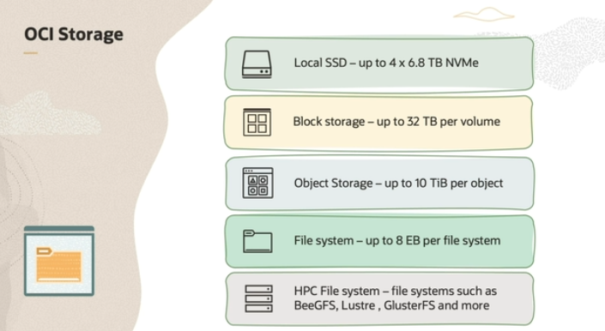

1. **OCI Storage Options**: OCI (Oracle Cloud Infrastructure) offers different types of storage, allowing you to choose the best option based on your needs:
   * **Local SSD (Solid State Drives)**: You can use up to 4 NVMe (a high-speed type of SSD) drives for very fast, local data storage.
   * **Block Storage**: This is a type of storage that can go up to **32 terabytes** per volume. It works well for tasks that need fast, reliable access to data, like databases.
   * **Object Storage**: This is useful for storing large files (like videos or backups), and you can store up to **10 terabytes** in a single object.
   * **File Systems**: These can grow very large, up to **8 exabytes** (1 exabyte is 1 million terabytes), making them ideal for managing massive amounts of data in a structured way.
2. **Redundancy for Data Protection**: OCI’s file system is designed for **resiliency**. It stores your data in **five different locations (fault domains)**, so even if something happens to one of those locations, your data is still safe and accessible.
3. **HPC File Systems**:
   * **HPC (High-Performance Computing) file systems** like **BeeGFS** are available. These are designed to handle very large-scale computing tasks that need fast access to huge amounts of data, often used in scientific research, simulations, or big data processing.
   * OCI makes it easy to deploy these HPC file systems through the **Oracle Cloud Marketplace**, where you can quickly set up various high-performance file servers.

**Simplified Summary:**

In OCI, you can choose from a range of storage options depending on your needs, whether it's super-fast SSDs, big blocks of data, or huge file systems. To keep your data safe, they store it in five different places, so if one location fails, your data is still protected. If you're running large-scale, data-heavy tasks, you can use specialized HPC file systems, and OCI makes it easy to set these up through their marketplace.

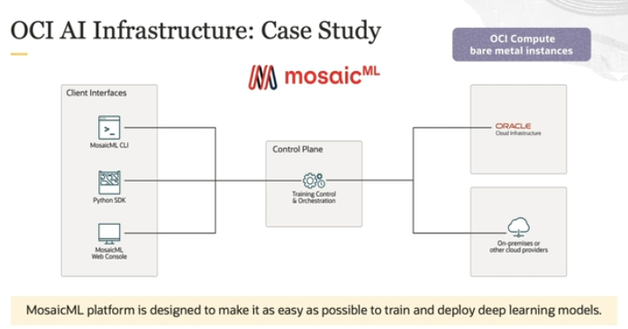

The **MosaicML platform** helps make training and deploying deep learning models easier. Here's how it works:

1. **AI Models**: It starts with advanced AI models that you can either train from the beginning or use **pre-trained models** that MosaicML provides.
2. **Training Recipes**: They also give you tried-and-tested methods to train your models efficiently.
3. **Pre-Trained Checkpoints**: These are models that have already been trained, and you can adjust them with your own data to make them work better for your specific needs.

For **large-scale AI tasks**, like training large language models (LLMs), **OCI SuperCluster** offers a very fast and powerful setup. It includes:

* **Low-latency networking** (quick communication between machines),
* **High-speed storage**, and
* **Strong computing power** using NVIDIA A100 and H100 GPUs, which are specialized for AI tasks, along with **ConnectX SmartNICs** for efficient networking.

In short, MosaicML simplifies the AI model process, and when you need a lot of computing power, OCI SuperCluster provides a fast and strong platform for large-scale tasks.